Quantum Boltzmann Machines (QBM)

1. Problem
Boltzmann Machines are probabilistic generative models used for unsupervised learning, density estimation, and feature learning. Classical Boltzmann Machines model probability distributions using energy-based formulations, but they become computationally expensive for large systems.
Quantum Boltzmann Machines (QBMs) extend this idea by replacing classical energy functions with quantum Hamiltonians, allowing quantum effects such as superposition and entanglement to represent complex probability distributions.

2. Intuition
A Quantum Boltzmann Machine works by:
- Defining a quantum Hamiltonian whose low-energy states represent likely data patterns
- Preparing the system in a thermal (Gibbs) state
- Sampling from the quantum system to learn or generate data
Quantum effects enrich the model’s expressive power compared to classical Boltzmann Machines.

3. Model / Circuit Structure
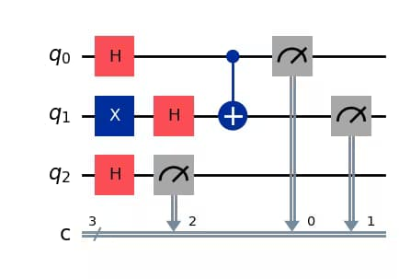

A typical QBM consists of:
- Visible Qubits
Represent observed data variables.
- Hidden Qubitss
Capture correlations and latent features.
- Quantum Hamiltonian Evolution
Includes interaction terms and transverse fields.
- Measurement / Sampling
Measurement outcomes correspond to samples from the learned distribution.

4. Simple Math Involved
- Quantum Hamiltonian: [ H = i b_i Z_i + {i<j} w_{ij} Z_i Z_j + _i _i X_i ]
- Gibbs (thermal) state: [ = ]
- Learning objective:
Maximize the log-likelihood of data samples under the model distribution defined by ().

5. Python Code (Quantum Boltzmann Machine – Algorithm)
import numpy as np
from qiskit import QuantumCircuit
from qiskit.quantum_info import SparsePauliOp
from qiskit.primitives import Sampler

num_visible = 2
num_hidden = 1
num_qubits = num_visible + num_hidden

np.random.seed(42)
bias = np.random.uniform(-1, 1, num_qubits)
coupling = np.random.uniform(-1, 1, (num_qubits, num_qubits))
paulis = []
coeffs = []
for i in range(num_qubits):
term = ["I"] * num_qubits
term[i] = "Z"
paulis.append("".join(term))
coeffs.append(bias[i])

for i in range(num_qubits):
for j in range(i + 1, num_qubits):
term = ["I"] * num_qubits
term[i] = "Z"
term[j] = "Z"
paulis.append("".join(term))
coeffs.append(coupling[i, j])

hamiltonian = SparsePauliOp(paulis, coeffs)
qc = QuantumCircuit(num_qubits)

for q in range(num_qubits):
qc.h(q)

for i in range(num_qubits):
qc.rz(bias[i], i)

for i in range(num_qubits):
for j in range(i + 1, num_qubits):
qc.cx(i, j)
qc.rz(coupling[i, j], j)
qc.cx(i, j)

qc.measure_all()

sampler = Sampler()
job = sampler.run(qc, shots=2048)
result = job.result()

distribution = result.quasi_dists[0]

print("Quantum Boltzmann Machine sample distribution:")
for state, prob in distribution.items():
print(f"{state}: {prob:.4f}")

6. Where the Algorithm Is Useful
- Generative modeling
- Quantum-enhanced unsupervised learning
- Modeling complex probability distributions
- Quantum statistical mechanics

7. Limitations
- Thermal state preparation is difficult
- Training is computationally expensive
- Limited practical implementations
- No proven quantum advantage yet

8. Comparison with Classical Boltzmann Machines
- Energy function: Classical uses scalar energy; QBM uses quantum Hamiltonians
- Correlations: QBM captures quantum correlations
- Sampling: Classical MCMC vs. quantum sampling
- Maturity: Classical BMs are established; QBMs are mostly theoretical

9. One-Sentence Summary
Quantum Boltzmann Machines are quantum generative models that learn probability distributions using quantum Hamiltonians and thermal state sampling.

